**PART #1**

* 1. **Short Summary:** The purpose of the website is to be an effective and credible demonstration of my skillsets as a rising senior, majoring in Mathematics and Computer Science with a minor in Data Science. If done successfully, it will be a two-way win, this website will help attract recruiters for internship and full-time roles in suitable positions and also improve my skills with HTML, CSS, and JavaScript. The main audience for the website will come from a fairly technical background including the likes of recruiters, and fellow students.
  2. **Persona Diagram:**

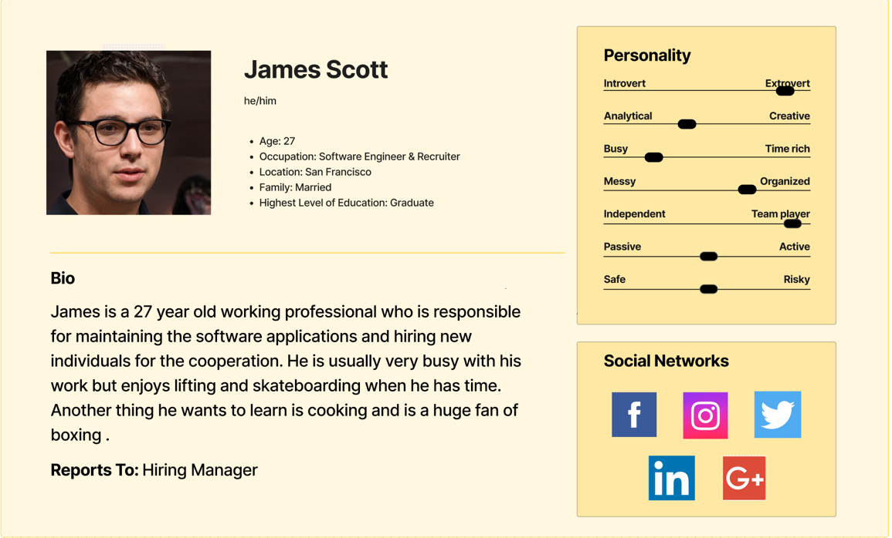

1. **Site Diagram:**

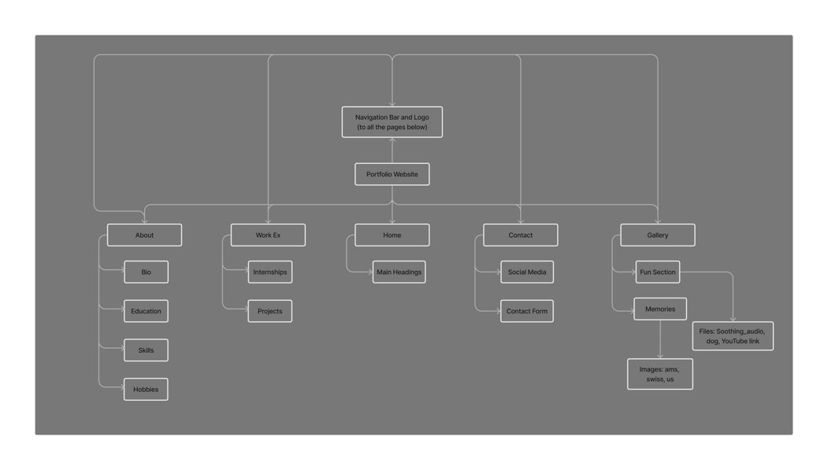

1. **Wire Frames:**

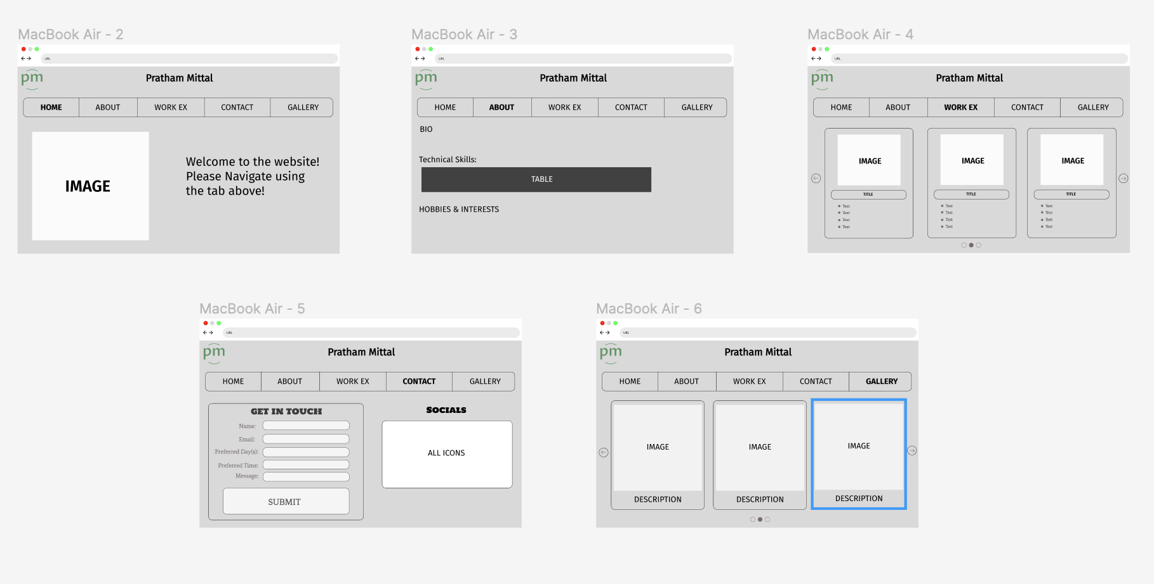

1. **Technical Requirements:**
   1. **Host:** Currently it’s being hosted through Netlify but once it’s fully built, I would want to host it using AWS.
   2. **Technology:** Different technologies like HTML, CSS, JavaScript, PHP, Local Storage can be used for front end development and storage of data respectively.
   3. **Target Browser:** Most of the modern browsers including Google Chrome and Safari.
   4. **Device Profile:** Need to make sure that the deliverable works smoothly and is accessible on different devices including laptop and mobile phones.
   5. **Page Delivery Targets:** Needs to be done in the least possible time with minimal requests to the server.
2. **Content Requirements:**

I need to gather more information about my work experience and have it properly presented on the website. Just to have them listed isn’t the best usage of words to form a sentence in order to convey the exact responsibilities that I had, and as a resultant of that what skills I have picked is the more accurate demonstration of skills. In addition to this, I feel I need to brainstorm ideas as to what other visual ways are there to present information with the help of bar charts, pie charts.

1. **Extra Credit:**
   1. Done
   2. Developers couldn’t make use of the ‘MATHML’ tag until now due to its limited browser support. It extends to not working on many user ends due to the incompatibility. Also, there are alternativc methods available now so developers don’t want to rush into complex models.
   3. Done

**PART #2**

Link: <https://glittery-torrone-f185d5.netlify.app>

